**QUERIES AND NORMAL TESTING IN MY SQL**

Group- 25

Ankit Sharma – 055059

Himanshi Sharma- 055012

**1. Project Information**

The **Banking Database Management System (DBMS)** project aims to design a comprehensive relational database to efficiently manage core banking operations such as customer onboarding, account handling, nominee assignment, document management, and service request tracking.

This database ensures a structured, reliable, and scalable platform, supporting both operational needs and managerial decision-making processes in a banking environment.

The system consists of the following key tables:

* **Bank Customers:** Stores customer personal details and identification information.
* **Accounts:** Captures customer bank accounts, types, deposits, and branch codes.
* **Nominees:** Manages information about nominees linked to customer accounts.
* **Documents:** Maintains KYC documents like PAN, Aadhaar for each customer.
* **Service Requests:** Tracks customer service requests such as cheque books, debit cards, and account closure.

Each table is carefully linked through primary and foreign keys to maintain referential integrity and ensure efficient data retrieval.

**2. Project Objective**

The objective of the **Banking Database Management System (DBMS) project** is to:

* **Design and implement** a normalized relational database using MySQL for effective banking data management.
* **Ensure Data Normalization** up to the **First Normal Form (1NF)**, maintaining atomicity, uniqueness, and eliminating redundancy.
* **Perform DDL operations** such as ALTER, DROP, MODIFY, and RENAME to demonstrate database schema flexibility.
* **Populate the system** with realistic dummy data (including intentional NULL values) to simulate real-world banking scenarios.
* **Execute Stress Testing** through multiple **Insert, Update, and Delete operations** to validate the database’s robustness under operational conditions.
* **Develop and analyze Situational Queries** to extract business insights related to customer behavior, service issues, and account management.
* **Support Regulatory Compliance** by ensuring that critical KYC documentation is linked to each customer.
* **Provide Managerial Insights** enabling better decision-making, improved customer service, and efficient resource management across bank branches.

**3. Creating Data Insertion**

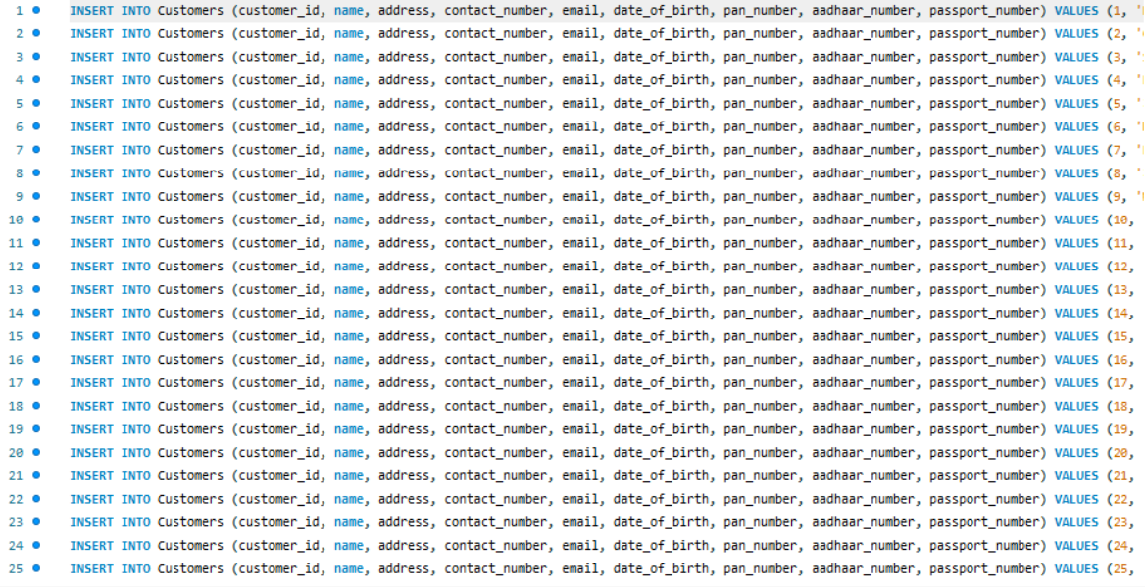

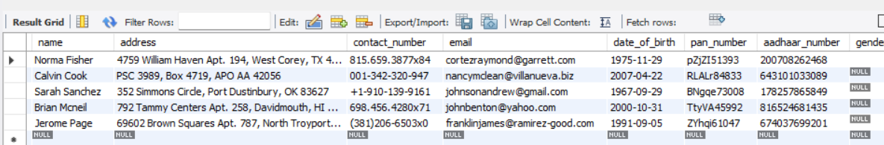

**4. DDL Operations**

**ALTER:**

* Add a new column
* Remove a column
* Modify a data type
* Add a constraint
* Remove a constraint
* Rename a table
* Rename a column

**5.Checking Normalization – 1st Normal Form (1NF)**

What is 1NF (First Normal Form)?

A table is in First Normal Form (1NF) if:

1. Each column has atomic values (indivisible)
2. Each row is unique
3. There are no repeating groups or arrays in a single column

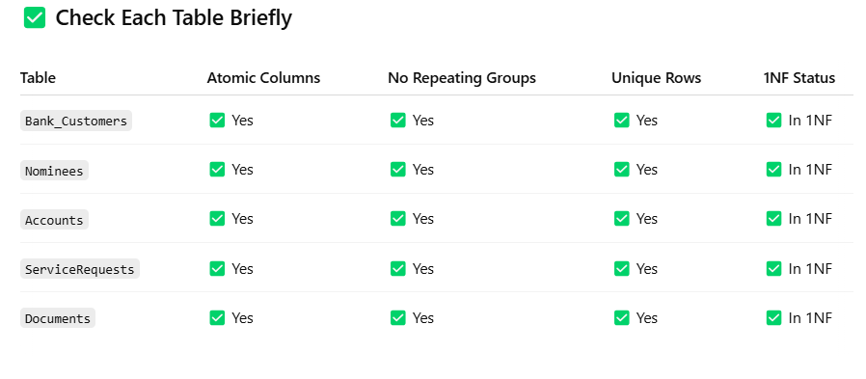

**Managerial Insight You Can Add to Your Report:**

All tables in our database satisfy the First Normal Form (1NF) as each field contains atomic data, no multi-valued attributes are present, and primary keys ensure row uniqueness.

**6. Stress Testing – Insert, Update, Delete**

**1. INSERT Operation**

Add a new customer and their account, nominee, service request, and document.

**2. UPDATE Operation**

Update an existing customer’s email and deposit amount.

**3. DELETE Operation**

Remove a customer and cascade-delete related records (if ON DELETE CASCADE is set up

**The screen shot of My SQL bench shows that data named Karan Mehta is deleted**

**4.DELETE Operation (Stress Test)**

We will:

1. Safely delete all records related to 'Karan Mehta'
2. Maintain referential integrity by deleting dependent records from all tables

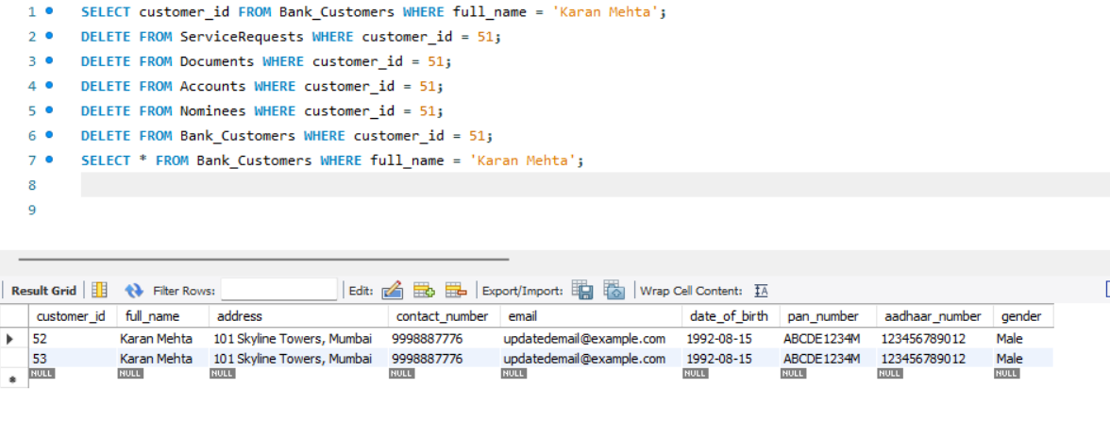The system passed the stress test. The database supports insertions, updates, and deletions while maintaining referential integrity across all linked tables.

**7.Situational Queries & Analysis?**

**a**. Find customers who have not provided their PAN number — important for KYC.

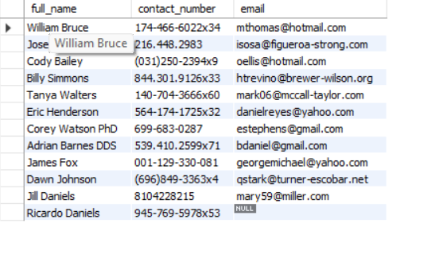

This screenshot shows list of people who have not provided their PAN-number which is important for KYC

b. Find the **top 5 customers with the highest initial deposit** amounts.



These high-value customers can be targeted for premium services or relationship management.

c. Find accounts that have **no specified mode of operation**.



These accounts may require additional documentation or clarification from customers.

d. Find customers whose **service requests are still pending**.



These customers are awaiting service. Service teams should prioritize these cases.

e. Find customers who are **young (born after the year 2000)**.



f. Identify customers who have not provided an email (important for digital communication).



These customers should be encouraged to update their email for better communication.

g. Find out how many customers are Male, Female, or Others.

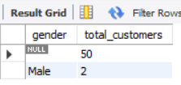

h. Accounts with Initial Deposit Less Than 5000

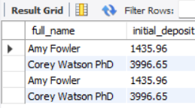

These are the information of the account holder and their initial deposit which is less than 5000

i.Average Initial Deposit by Account Type

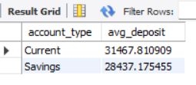

Useful for strategic planning of banking products.

j.Customers Whose Contact Numbers Are Missing



This shows that contact number is available for every client in the database management system.

**8. Managerial Implications**

The implementation of the Banking Database Management System brings several key managerial advantages:

* **Enhanced Customer Management:**  
  Centralized customer information enables banks to build stronger relationships, offer personalized services, and ensure higher satisfaction levels.
* **Operational Efficiency:**  
  Structured storage of accounts, documents, and service requests allows for faster retrieval of customer data, improving branch-level operational turnaround times.
* **Regulatory Compliance:**  
  Integrated tracking of KYC documents ensures that the bank remains compliant with mandatory regulations, reducing the risk of penalties.
* **Business Intelligence:**  
  Situational queries provide deep insights into customer behavior patterns, service gaps, and branch performance, helping managers make informed decisions.
* **Risk Management:**  
  Proper record-keeping and validation through stress testing ensure system resilience, minimizing risks related to data loss, duplication, or service delays.

Overall, the database acts as a strategic asset that enables better planning, customer segmentation, service improvement, and regulatory adherence, directly impacting business growth and reputation.

**9. Conclusion**

In conclusion, the Banking Database Management System project successfully achieved its intended objectives by designing a normalized, relational database structure tailored for banking operations.

Through the application of First Normal Form (1NF) normalization, DDL operations, dummy data insertion, stress testing, and situational query analysis, the project demonstrates the database’s ability to maintain data integrity, support operational needs, and generate valuable managerial insights.

The system not only facilitates efficient management of customer, account, and service request information but also strengthens compliance and strategic decision-making capabilities.  
This project lays a strong foundation for future enhancements like real-time analytics, mobile banking integration, and customer relationship management (CRM) systems, making it adaptable to evolving business and technological landscapes.